Optical properties of amorphous and polycrystalline Sb₂Se₃ thin films prepared by thermal evaporation
Chao Chen¹, Weiqi Li², Ying Zhou¹, Cheng Chen³, Miao Luo¹, Xinsheng Liu¹, Kai Zeng¹, Bo Yang¹, Chuanwei Zhang², Junbo Han³, Jiang Tang^{1, a)}

1. Wuhan National Laboratory for Optoelectronics (WNLO) and School of Optical and Electronic Information, Huazhong University of Science and Technology, Wuhan, 430074, Hubei, P. R. China
2. State Key Lab of Digital Manufacturing Equipment and Technology, Huazhong University of Science and Technology, Wuhan 430074, Hubei, P. R. China
3. Wuhan National High Magnetic Field Center, Huazhong University of Science and Technology, Wuhan, 430074, Hubei, P. R. China
a) Author to whom correspondence should be addressed at jtang@mail.hust.edu.cn.

- Composition analysis of a-Sb₂Se₃ and c-Sb₂Se₃ thin films
We performed energy-dispersive X-ray (EDX) spectroscopy analysis on our a-Sb₂Se₃ and c-Sb₂Se₃ films deposited with substrate temperature of room-temperature and 290 ºC. For both samples, three randomly selected spots were measured and data were averaged. The molar ratios between Se and Sb in a-Sb₂Se₃ and c-Sb₂Se₃ samples were 1:1.54 and 1:1.52, respectively (Table SI), indicating the films were actually slightly Se rich.

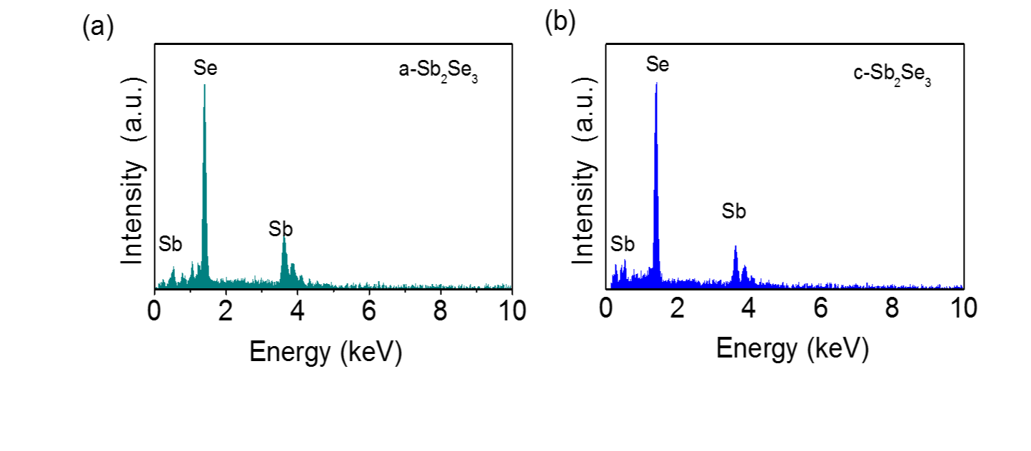
Fig. S1. Representative EDX spectra for (a) a-Sb₂Se₃ and (b) c-Sb₂Se₃ films deposited at substrate temperature of room-temperature and 290 ºC. For EDX measurement, the working distance is 5 mm and the beam voltage is 10 kV.

Table SI. EDX results of a-Sb₂Se₃ and c-Sb₂Se₃ films
No. | a-Sb₂Se₃ |  |  | a-Sb₂Se₃
No. | Sb (At%) | Se(At%) | Sb:Se(At%) | Sb(At%) | Se(At%) | Sb:Se(At%)
1 | 39.32 | 60.68 | 1:1.54 | 39.78 | 60.22 | 1:1.51
2 | 39.28 | 60.72 | 1:1.55 | 39.65 | 60.35 | 1:1.52
3 | 39.40 | 60.60 | 1:1.54 | 39.81 | 60.19 | 1:1.51
Average | 39.33(5)* | 60.67(5) | 1:1.54 | 39.75(7) | 60.25(7) | 1:1.52
*The value in bracket is the standard deviation.
- The mean crystal grain size
The mean crystal grain size 69.9 nm in the c-Sb₂Se₃ was estimated from XRD by Debye-Scherrer equation (S1).
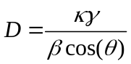 (S1)
D is the mean size of the crystalline domains; κ is Scherrer constant (κ=0.89); γ is the X-ray wavelength (γ=0.154056 nm); β is the diffraction peak width at half the maximum intensity (FWHM); θ is the Bragg angle. The mean crystal grain size in c-Sb₂Se₃ from XRD was shown in Table SII.
Table SII. The mean crystal grain size in the c-films from XRD
Peak location  (2θ/º) | Crystal indices  (h k l) | Half peak width β  (2θ/º) | Grain size D  (nm)
15.034 | ( 0 2 0) | 0.203 | 77.8
16.88 | ( 1 2 0) | 0.196 | 83.5
27.411 | ( 2 3 0) | 0.215 | 71.2
31.168 | ( 2 2 1) | 0.229 | 63.9
32.234 | ( 3 0 1) | 0.22 | 68.7
45.584 | ( 0 0 2) | 0.254 | 56.1
SD* | / | / | 8.9
average | / | / | 70.2
*SD is short for standard deviation.
- Photoluminescence (PL) of Sb₂Se₃
The measurement of PL was taken in the temperature range of 84-180K.The test instrument consists of Ti : Sapphire laser (Mira 900, Coherent; 76 MHz, 130 fs), near-infrared spectrograph (Acton SP 2358), InGaAs near-infrared detector (OMAV：512/LN ). Before testing, we used high quality InP crystal and copper zinc tin sulfide (CZTS) film to calibrate the instrument. The test signals of Sb₂Se₃ films were noisy (Fig. S2.). We have reasons to believe that the PL of Sb₂Se₃ were not found in our setup at 84-180K
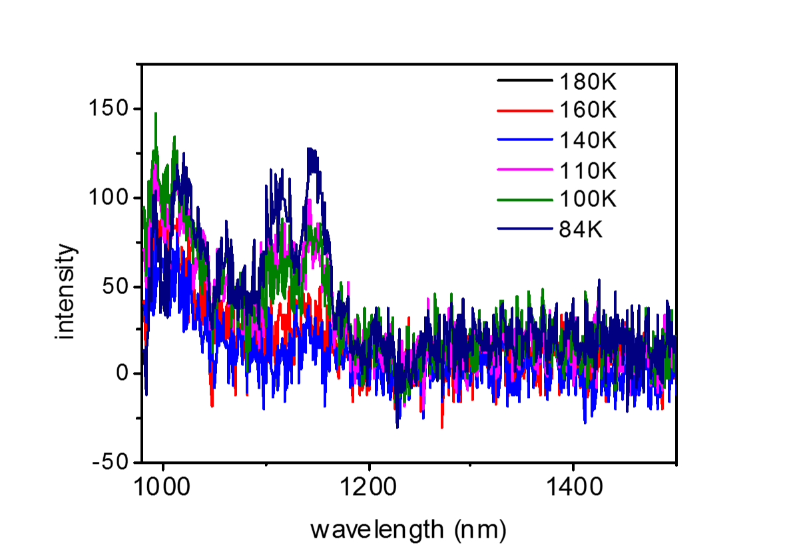
Fig. S2. Photoluminescence (PL) of c-Sb₂Se₃ in the temperature range of 84-180K.

- Swanepoel’s envelope method using in Sb₂Se₃ thin films
In order to ensure the credibility of the refractive index getting from EM, we have verified the results by Swanepoel’s envelope method¹. The transmittance spectra was recorded in the wavelength range of 400-2615nm using UV/VIS spectrometer Lambda 950 (Perkin Elmer) and interference was observed (Figure S3). TM and Tm are the upper and lower envelope curves of the transmittance spectra. According to Swanepoel’s envelope method, values of the refractive index, n, can be computed as (S2).
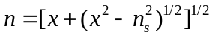 (S2)
where
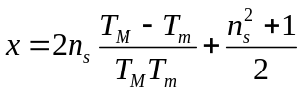 (S3)
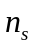is the refractive index of the substrate, which could be calculated using following formula (S4)
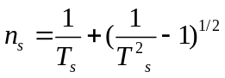 (S4)
where 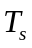 is the transmissivity of soda lime glass. For convenience, the refractive indexis approximately 1.52 at long wavelength.
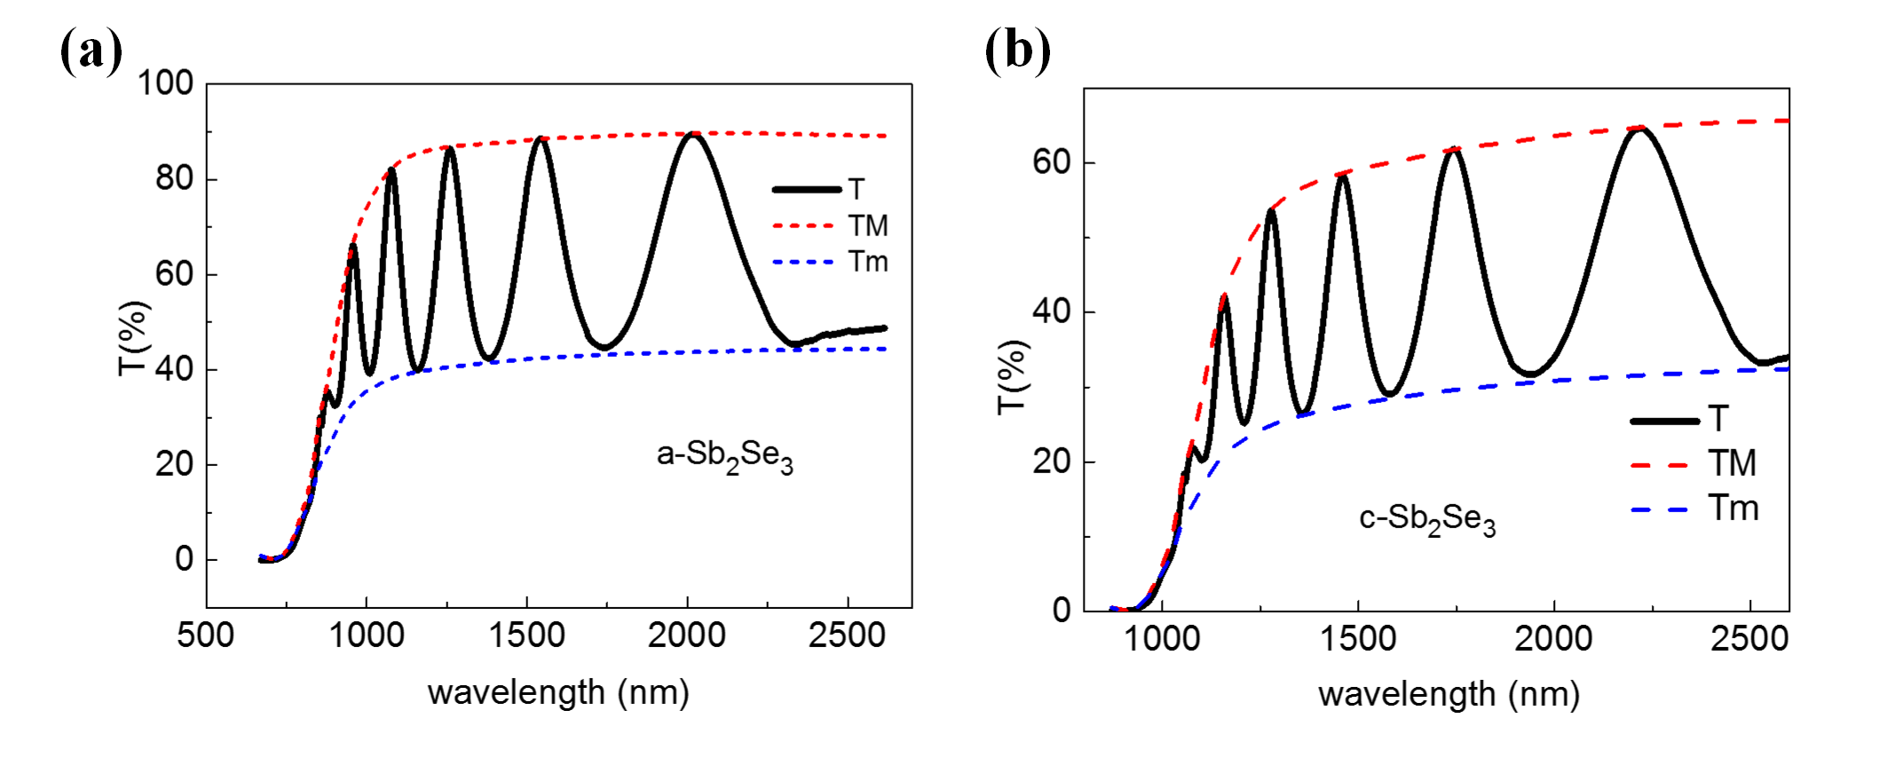
Fig. S3. The transmittance spectrums of (a) a- Sb₂Se₃ and (b) c-Sb₂Se₃ thin ﬁlms in the wavelength range of 400-2615nm.

References:
¹R. Swanepoel, J. Phys. E 17, 896 (1984).

